厦门迪太进出口有限公司
XIAMEN DITAI IMP.& EXP. CO.,LTD
地址：中国厦门禾祥西路鸿升大厦8A
8FL, Hongsheng Building, West Hexiang Road, Xiamen, Fujian, China
TEL:0592-26808108 Phone:+8615160094689 FAX:0592-2680880 E-mail: irene.zhang@xmditai.com
----------------------------------------------------------------------------------------------------------------------

Ammonium Molybdate Tetrahydrate CAS 12207-64-6

Ammonium Molybdate Tetrahydrate CAS 12207-64-6 Quick Details

Chemical Name: Ammonium Molybdate 4-HYDRATE
CAS No.: 12207-64-6
Molecular Formula:4MoO3.3H2MoO4.4H2O.6H3N
Molecular weight: 1235.85
Appearance: colourless to light green crystalline solid

Ammonium Molybdate Tetrahydrate CAS 12207-64-6 Properties
Colorless or pale yellow-green diamond-shaped crystal, relative density 2.498g/m3(20°C). Stable in the air, its aqueous solution is weakly acidic, the solubility in the aqueous solution of 20° C and 80-90°C, respectively, equal to 300 g / l and 500 g / l. Heated to 90°C, will loss a water of crystallization, 170 ~ 190°C, broken down into ammonia, water, and molybdenum trioxide. Placed air weathering, and lose some ammonia. Soluble in water, acid and alkali, and insoluble in ethanol. Toxic, the maximum allowable concentration in the air is 2mg/m3.

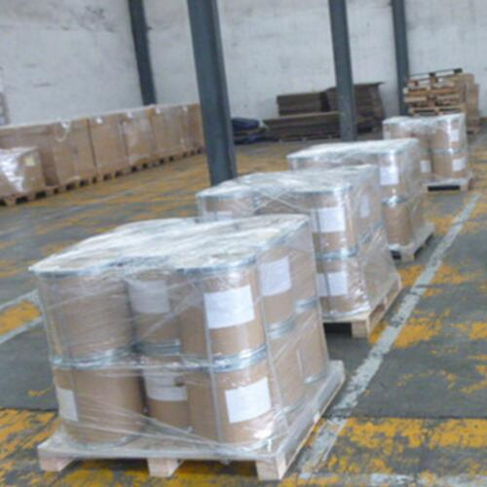

Ammonium Molybdate Tetrahydrate CAS 12207-64-6 Use

Fertilizers and Micronutrients,
Pigment,
Ceramics,
Paint,
Pharmaceutical,
Electroplating,
Petroleum and Coal Technology,
Analytical Reagent.

