**厦门迪太进出口有限公司**

**XIAMEN DITAI IMP.& EXP. CO.,LTD**

**地址：****中国厦门禾祥西路鸿升大厦8A**

**8FL, Hongsheng Building, West Hexiang Road, Xiamen, Fujian, China**

**TEL:0592-26808108 Phone:+8615160094689 FAX:0592-2680880 E-mail: irene.zhang@xmditai.com**

**----------------------------------------------------------------------------------------------------------------------**

**Pyrogallol CAS 87-66-1 good quality**

**Pyrogallol CAS 87-66-1 good quality Basic details**

|  |  |
| --- | --- |
| Product name | Pyrogallol |
| Cas number | 87-66-1 |
| Molecular formula | C6H6O3 |
| Molecular weight | 126.11 |
| Appearance | White Powder |
| Melting point | 43-47 °C(lit.) |

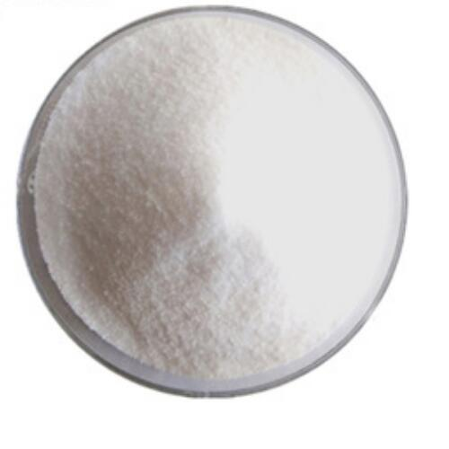

**Pyrogallol CAS 87-66-1 good quality Physical properties**

Pyrogallol is an organic compound with the formula C6H3(OH)3. It is a white water-soluble solid although samples are typically brownish because of its sensitivity toward oxygen. It is one of three isomeric benzenetriols.

White odorless crystals. It has a bitter taste. Exposure to air and light turns gray. Slowly heat and begin to sublimate. The melting point of 133-134 ° C, the boiling point of 309 ° C, the relative density of 1.453, the refractive index of 1.561 Soluble in water, ethanol, ether, slightly soluble in benzene, chloroform, carbon disulfide. When exposed to air, the color of the aqueous solution darkens and the caustic solution discolors faster.

**Pyrogallol CAS 87-66-1 good quality application:**

**Pyrogallol is mainly used for manufacturing melaminoformal dehyde resin, which is well water, heat and arc resistant and bright. It can also be used in decorative laminates, aminoplastics, adhesive agents, coatings and used as a paper reinforcing agent, textile auxiliaries, cement water-reducing agent and leather retaining agent**

